**CHAPTER 1**

**INTRODUCTION**

The popular and classic game which is enjoyable while playing and is my all-time favorite selected game is a Snake Game, which I've been playing since I was a kid, which is know presented through a modern touch of technology. The Snake Game Using Hand Tracking/Gesture Recognition is Game name where the tips of a particular hand of the human is detected and used to manipulate the movements of the snake which is detected through the web cam or the camera of the system. It is the concern of the user to avoid t the snake to intersect itself where the snake head touches the remining body of the snake and should no stop the hand movement while playing the game if it comes off then the game is over

To director the user or the player about the game or the projection of the body of the snake I used a green colored round shape as a pointer for the head of the snake in the game and green color line surrounded by the red limitations. Hands are used for controlling the game-based interfaces for snake games as an alternative for using keys of the keyboard or touching a mouse.

In this game has you continue playing you get more and more food items which the player has to

eat white playing and keeps growing the body of the snake and the game is getting difficult to play

the game

CV2 and CVZONE are the libraries used for the development of the game. This project is fragment of the field of hand recognition through the camera, which is booming in gaming industries and gaining more popularity because it allows users to gain best gaming experience while playing the game.

Over this attempt of developing the game for people who want to play video games as they play motions detecting games, they don’t need to purchase expensive consoles showing that they can be done through a simple system camera setup.

* 1. **Objective Of the Project**
* To advance and improve the gaming experience of video gaming by enabling people to function the video game using the hand recognition.
* To give user approachable and easy to use interface for playing recognition games.
* To fascinate gamers toward video gaming as there is lots of scope of in this field
* To avoid controller like keyboard, mouse or joysticks for playing the games as by using this technology they can make more realistic sensing games
* To build recognition or motion video games without necessity of exclusive gaming setup

and added gaming controllers.

* To bring motion/ recognition sensing games at very economical cost for user where there will be no need of buying the expensive consoles for a normal PC or video games.
* To explore and study recognition / gesture technology.
* To detect the limitations for technology and make it better for further implementation
* To apply the gesture / recognition technology in current games.
* To develop understanding of python programming.
  1. **Report Organization**

Report thesis organization provides what are the activities that are carried in entire project. The thesis of this project is explained as follows:

* + - The **chapter 1** presents the compact introduction of the project with its aim.
    - The **chapter 2** presents detailed literature survey of existing system and technologies that this project uses.
    - The **chapter 3** gives software requirements specification that gives software and hardware this project uses.
    - The **chapter 4** gives System analysis.
    - The **chapter 5** provides System Design to explain hoe components are interconnected
    - The **chapter 6** gives System implementation.
    - The **chapter 7** gives System testing that I conducted to ensure the quality of the system.
    - The **chapter 8** gives the results of the system
    - The **chapter 8** concludes the project and provides future enhancement that can be taken.

**CHAPTER 2**

**LITERATURE SURVEY**

Literature survey is a methodology of identifying the features that provided by various existing system, investigate to understand what are pros and cons of the project. That makes us to understand what are the problems in the existing system and what are the extra feature that are in existing system that helps us to decide what are the functionalities the system will provide.

**2.1. Survey On Existing System**

**2.1.1 Hand Gesture Controlled Gaming Application**

The paper[1] is Computer technology has tremendously grown over the past decade and has become a necessary part of everyday live. The primary computer accessory for Human Computer Interaction (HCI) is the keyboard. The keyboard is not suitable for HCI in some real life situations, such as with Human Robot Interaction (HRI). The most natural and intuitive technique for HCI, that is a viable replacement for the computer keyboard is with the use of hand gestures [3]. This system is therefore aimed at investigating and developing a Computer Control (CC) system using hand gestures. In order to harness the full potential of a webcam, it can be used for vision based CC, which would effectively eliminate the need for a computer keyboard. The usefulness of a webcam can also be greatly extended to other HCI

**2.1.2** **Human Computer Interaction: Game Developed in Python using Gesture Recognition**

The paper[2] decided to work on is the classic snake game. This is a game in which, the user uses a red coloured object and moves it around in front of a webcam so that a trail follows the object on its image and represents the shape of a snake. The size of this snake keeps on increasing in size and the game becomes progressively more difficult to play. This project has been coded in Python . The libraries used are NumPy and OpenCV . This project is considered to be under the field of gesture recognition which is a field which is gaining widespread popularity as it makes it very easy for the user get some particular tasks done. Gesture recognition has slowly but surely created a stronghold in the gaming industry and now moving beyond it in every aspect. Together with computer vision it is enabling for a much better user experience and dynamic and user-friendly interfaces.

**2.1.2 Snake Game Using Hand Recognition System**

The paper[3] You can see me playing my all-time favorite game, which I've been playing since I was a kid, in this project. Snake Game is the name of the game. Gestures are used to manipulate the snake's position on the screen. It's your responsibility to keep the snake from hitting the wall boundaries because if it does, the game is finished. For guiding the snake, I utilized a blue-colored item as a pointer. Gestures are used as commands in vision-based interfaces for video games instead of clicking keys on a keyboard or moving a mouse. To give the user a more natural experience, these interfaces must allow for unintentional movements and continuous gestures. The traditional snake game is the subject of the paper I choose to concentrate on. This is a game in which the user manipulates a red object in front of a webcam to create a trail that follows the object's image and resembles the shape of a snake. The snake's size keeps growing, and the game becomes increasingly tough to play.

Active Shape Models have been proved to provide a reasonable premise for realtime include following, primarily in the 2D space. The procedure's ability to stretch out to 3D is a major concern. The Point Distribution Model that was used effectively expands into three aspects, However, in this scenario, the capacity to follow only 2D video sequences for input is a constraint. Sound system vision or data concealment are two possible paths.

**2.2 Existing System**

Most of the existing System have following drawbacks:

* In the existing system some of these have only the gesture control where the system can detect only the direction of the fingers of the hands and the snake moves in towards the direction of the hands without tracking the path of the snake.
* Some of these have pre-defined data set for the system where the system detects the hands based upon the data set given to the system and the movement of the snake is decided
* And some of these are cursor based which are functioned through mouse, joy stick or touch-pad for playing the game which

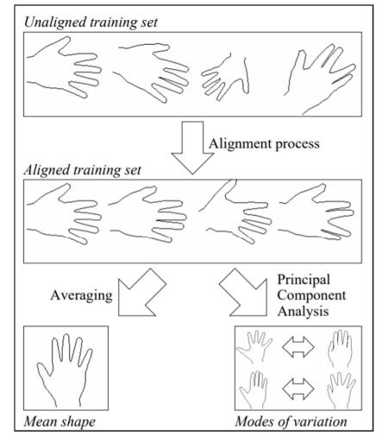

**Fig 2.1 Trained dataset**

**2.3 Proposed System**

In the system we are using the hand recognition technology where t the game starts as soon as the system detects the finger tip of the particular hand and the snake movement is depend on the movement of the hands where there is no delay for on screen display of the game and after the game is over there is a separate on screen display shoeing of the score of the user and the displaying the message of Game Over

**2.4 Hardware Survey**

## Web-Cam

**Fig 2.2 WEB-CAM**

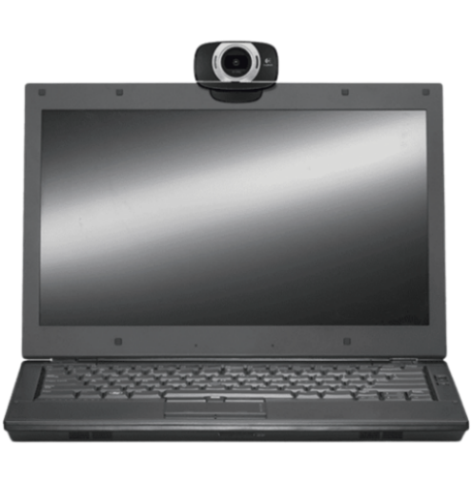

**Fig 2.3 Laptop and webcam setup**

Web-Cam or the laptop front camera is a mainly used device for this project where whole game runs through open webcam where there is window showing the user face where the user must show his hand Infront of the camera and detect the tips of the particular finger

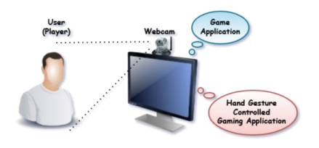

**Fig 2.4 Users setup with system**

* 1. **Tools / Technology**

## PyCharm IDE

* PyCharm IDE is python language based integrated Development Environment (IDE) it also provides smart code completion, code inspections, on-the-fly error highlighting and quick-fixes, along with automated code refactoring’s and rich navigation capabilities it also provides software development, game development, C++ Tools, Data Tools
* PyCharm also gives built in features and we can download any modules which are required for the project in the ide itself where the it becomes easy to use and much more user friendly for coding and developing the project
* As an IDE for Python, JetBrains created the hybrid platform known as PyCharm. For the creation of Python applications, it is frequently employed. PyCharm is a popular Python IDE that is used by some unicorn companies like Twitter, Facebook, Amazon, and Pinterest. Versions 2.x and 3.x are supported. On Windows, Linux, or Mac OS, PyCharm can be used. It also includes modules and packages that facilitate the quick and easy development of Python-based software by programmers. Additionally, it can e modified in accordance with the demands of developers.
* **Essential features of PyCharm:**

We've listed a few of PyCharm's key features below.

* First, an intelligent code editor
* It facilitates the creation of superior code.
* It has colour schemes for terms, classes, and functions. This makes the code easier to read and comprehend and makes it simpler to spot mistakes.
* It offers the code completion instructions as well as an autocomplete capability.
* **Code Navigation:**
* It saves developers time and effort by making it easier to change and improve code.
* A developer can browse to a function, class, or file quickly and easily using code navigation.
* A programmer can quickly discover a variable, symbol, or element in the source code.
* A developer can further investigate carefully by using the lens mode.
* **Refactoring:**

Refactoring in PyCharm enables developers to improve the internal structure of the code without compromising the exterior performance of the code. It also helps separate up more extended classes and methods with the aid of the extract method.

* **Support for a Variety of Other Web Technologies:**

It supports HTML, CSS, JavaScript, and other well-known web technologies while also assisting Python developers in building web applications. With this IDE, programmers have the option of live editing. Developers may track changes immediately in a web browser with PyCharm, which also supports AngularJS and NodeJS for building web apps, and examine newly produced or modified web pages as they are being developed.

* **Support for Well-known Python Web Frameworks**
* Support for web frameworks like Django is provided by PyCharm.
* It offers the Django parameters autocomplete functionality and suggestions.
* It supports the Django code debugging process.
* The two others widely used web frameworks, web2py and Pyramid, are also helped by it.
* **Support for Python Scientific Libraries:**

The scientific Python libraries Matplotlib, NumPy, and Anaconda are supported by PyCharm. Projects involving data science and machine learning can be built with the aid of these scientific libraries. It can be integrated with many tools, including IPython, Django, and Pytest, and has interactive graphs that aid developers in understanding data. Innovative, cutting-edge solutions are aided by this integration.



**PyCharm IDE**

## Python

* Python is a generally accepted, dynamic, measured, utilitarian, and item-focused programming language. Ninety percent of people prefer Python over other innovations due to its simplicity and durability. It combines skilled programming with an efficient approach to programming improvement across a broad range of industries. Python introduces programming as the development of many open-source tools that support the creation of applications with exceptional levels of security and efficacy. Python practices practical and object-centered design concepts, which leads to the development of clear and practical code in
* With C/ObjC/Java/Fortran, Python can be interfaced instantly. Python's traditional explanation of procedural code, good care limits, accurate, understandable language structure, instinctive thing bearing, powerful data types, modules and increases helpfully written in C, C++, broad standard libraries and complete estimated quality, exceptional case-based error handling, and embeddable inside programming as a prearranging interface are some of its key features. Python is also compatible with the Internet Communications Engine (ICE) and many other compromise innovations.

**CHAPTER 3**

**SOFTWARE REQUIREMENT SPECIFICATION**

SRS (Software Requirement Specification) is most needed information as it shapes the software development process. SRS provides what are the technical aspects that are essential to build a successful system. It gives the clear-cut image of the set of things which act as a pillar to develop a system. In this phase it provides the idea of what the software and hardware product does in the system. It provides clear cut information about the project that is developed to the client and the developer.

* 1. **Types Of Requirements**

Our project includes both functional and non-functional requirements.

## 3.1.1 Functional Requirements

Functional requirements of our project explain the functionalities that must be provided by each module of our project.

The following are the functional requirements for our application as listed below,

* **Game Player**

The system user or the player who will be playing game should be aware of the game rules and must know how to use the IDE for playing the game.

* **User input**

The user input for this project are the human hands where the tip of the index finger of particular hands are detected and the game is run through that process

* **User interface**

The UI is very minimalist and is easy to use for the user for the best experience of the game play and the score displaying

* **Gameplay character**

The main character of this game is Snake and it is the object that the user has to paly within the screen provided to play for the user

* **Scoreboard**

Score is displayed after the game is over when user makes mistake in the game the game ends

with a message and displays the game score of the player

**3.1.2 Non-Functional Requirements**

These are the standards that outline criteria rather than specific behaviors that can be used to assess how well a system is functioning. Within these limitations, the system must function. An aspect of the system's performance is elaborated by the non-functional requirement.

* **Performance**

Interactivity in the app is required, as are shorter wait times. Therefore, there are no instant delays in any of the app's action-response interactions. This app's resource usage shouldn't be so high that it prevents the user from using the device. In case the user wants to use other programmers, the application should be able to run in the background.

* **Usability**

The application needs to be simple to use and navigate in the manner users would expect to without any delays. Quick navigation is expected in the app.

* **Reliability**

All of the functional specifications should be met by the app without any strange behavior. The gauge output must always warn the user of potential issues before displaying inaccurate or out-of-date data. As it attempts to prevent mistakes while entering data, the software is less prone to errors. When incorrect data is entered, the proper error messages are also shown.

* **Availability**

On the user's Android device, as long as it is in good functioning condition, the app will always be

accessible.

* **Maintainability**

Clear and concise writing should be used when creating the software. There will be thorough

documentation of the code. To guarantee that maintenance is simple, special care will be made when designing the program.

* **Speed of response**

A user-provided task should only require a very little amount of time for the system to accomplish. To complete the task, the application must answer right away.

* 1. **System Requirements**

As my project is Snake Game which is based on python, it requires software for coding and the only hardware is the camera. All these requirements to build effective game are called System Requirement. There will be always two types of software requirements one is minimal and Recommended software. It is best to use recommended software as industries prefer trendy one.

## Software Requirements

Software requirements specifies what are requirements to be satisfied to build a successful recognition game. Which is the software to be installed and also inbuilt modules that are required to operate the game flowless. The software that are required by the “Snake Game Using Hand Tracking/Gesture Recognition” are listed as follows:

* PyCharm IDE
* Windows (32- 64 bit) operating system.
* System which is connected to a web cam.

## 3.2.2 Hardware Requirement

As my project is purely based on programming language it requires python programming language to produce proper output.

* Processor: intel i3 and above
* RAM: minimum 2GB RAM but 4GB ram is recommended for smooth code development process.
* Hard Disk: need 150 MB space for developing successful code.
* Web Cam

**CHAPTER 4**

**SYSTEM ANALYSIS**

System analysis is a process of identifying the problems, collecting and elucidate the facts and understanding how the system will decomposed into its components. It is a process of identifying the objectives of the system or its parts. It is a technique of solving the problems that improves the quality of the system and its components that makes the system to work efficiently.

* 1. **Detailed Description of Project**

“The Snake Game Using Hand Tracking/Gesture Recognition” is Game name where the tips of a particular hand of the human is detected and used to manipulate the movements of the snake which is detected through the web cam or the camera of the system. It is the responsibility of the user to avoid the snake to intersect itself where the snake head touches the remining body of the snake and should no stop the hand movement while playing the game if it comes off then the game is over

To director the user or the player about the game or the projection of the body of the snake I used a green colored round shape as a pointer for the head of the snake in the game and green color line surrounded by the red boundaries. Hands are used for controlling the game-based interfaces for snake games as an alternative for using keys of the keyboard or touching a mouse.

In this game has you continue playing you get more and more food items which the player has to

eat white playing and keeps growing the body of the snake and the game is getting difficult to play

the game. Over this attempt of developing the game for people who want to play video games as

they play motions detecting games, they don’t need to purchase expensive consoles showing that

they can be done through a simple system camera setup.

**4.2 User Class Functions**

The system has following functionalities:

* Update position of the hand
* Manages the Camera
* He can view the final output that is giving on screen
  1. **Feasibility Study**

Feasibility study of this project will measure the operational, technical and cost factor. This will also help to check the operational outcome of the project, and helps to determine the technical support that are required to implement this project. Feasibility Study of the project helps to determine whether the project is technically feasible, checks is this project is built within the cost estimated.

The following are the main factors that were taken into account when analyzing the viability of our

suggested application:

Operational, technical, economic, and schedule feasibility are all important factors.

* **Functionality in Operation**

Once the system is built, it is considered to be operationally feasible if the available human resources

are usable. The system must be easy to use from the moment it is released. End users should have no

trouble using it. By "feasibility study," we frequently refer to research into these operating systems and frenzied speculation about computerizing various business models.

* **Technical Possibilities**

A technical feasibility analysis compares the amount of technology now in use to that which is required for the project's development. The development of platforms, software tools, and other elements make up the technology level. The idea is technically viable since the resources needed to develop it are already available. In order to be technically feasible, one must be aware of the technical requirements. Technical resource availability is referred to as having the necessary needs. The three types of technical resources include hardware, software, and network resources. In this situation, the analyst will need to determine whether any existing, reliable, relevant technology that satisfies the requirements. The ability of the technology currently in use to handle the solution is also determined.

* **Feasibility of a phase**

This presents the findings of a utility investigation of your time circle strategy for the design and

development of the many phases of programming bundle development. Project stages are mentioned.

The event most likely could be done in the allotted amount of time.

* **Fiscal Possibility**

This is the most crucial component of the project because it needs to be economically feasible in order

to be implemented. Since the hardware, a smart phone, is already available and the software is free,

there is no financial risk. Therefore, it is assumed that the system is financially viable.

It entails determining the expenses of the project's economic consequences, such as benefits and costs.

Calculating the company's investment fund for research & development and expenses is crucial. The

business had to purchase things even though it developed its software using open source. It aids in

figuring out the cash flow. It is useful in determining financial viability. To determine, calculate out the project's economic gain.

* **Possibility of a timetable**

A project's possibility of being finished within the anticipated time limit is known as schedule

feasibility. Schedule feasibility for this project is deemed to be high since it has a high chance of being finished by the target due date. In essence, resource optimization and timetable estimation are covered. Inadequate systems are worse than missed deadlines, which are bad enough. The possibility that a project can be completed within the timeframe it desires is characterized as the flexibility of plans. The timeline's viability is higher because this timetable has a higher chance of being completed by the intended deadline.

* **Feasibility for business**

To ascertain whether the project's aim can be accomplished with the resources allotted, commercial

feasibility should be examined. The following section will also clarify whether or not maintaining

development is crucial. Within the organization, we have a propensity to make advantage of the

technical know-how and resources currently available.

**CHAPTER 5**

**SYSTEM DESIGN**

The process in which different interfaces of the components and the data of the element such as the architecture, modules that goes through the system are designed by system design which also known as top level design. The views of system architecture and the implementation of the system elements and the architectural entities and the system information with sufficient detailed data are provided by the system design process. It focus on preparing the modules and the specification which are needed for the system and also how those modules are interconnected and how the data are shared from one to another to produce the system efficiently.

* 1. **Use Case Diagram of The System**

The fig 5.1 shown below represents the use case diagram of the project . In this project there will be two actors namely user and system. Each usecase represents the functionalities the actor can do. Here he starts game and then the system reacts to the user activitys

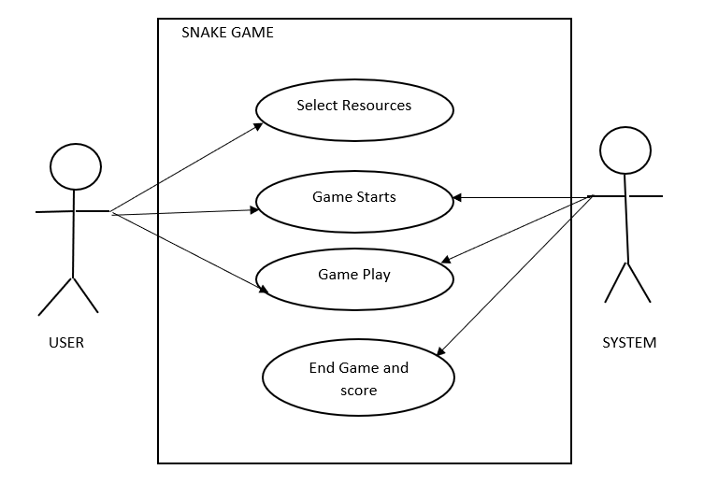

**Fig 5.1 Use Case Diagram for Snake Game**

* 1. **Activity Diagram of The System**

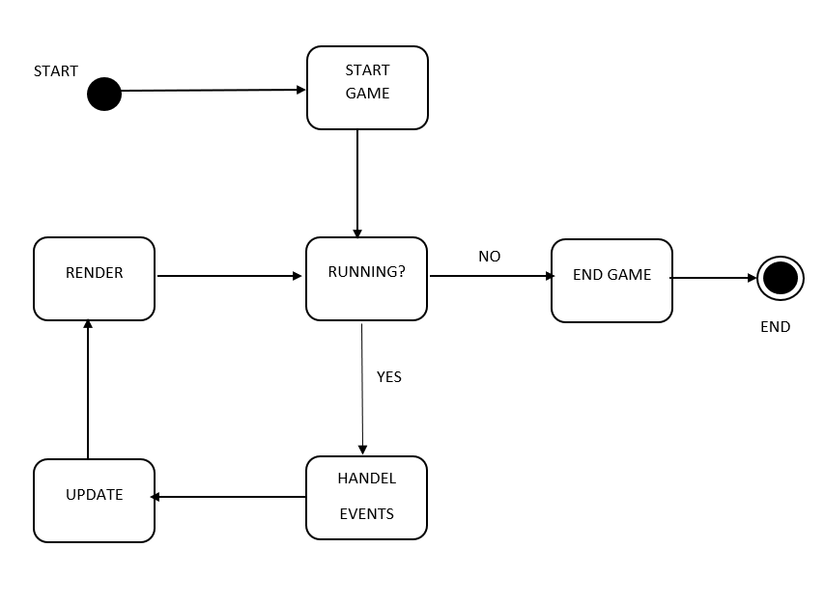

**Fig 5.2 Activity Diagram of The Snake Game**

The above figure 5.2 is the activity diagram where it shows how the game runs, what are the modules for that and shows how data flows through the phases of the game and how it works and ends

* 1. **Flow Chart of The System**

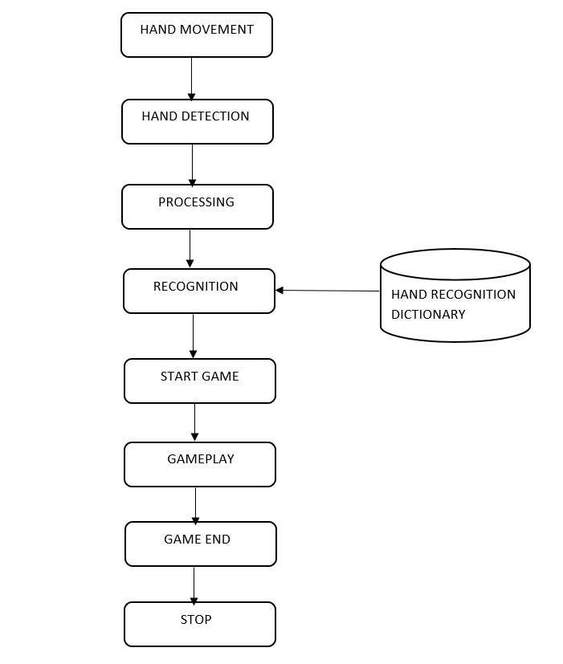

**Fig.5.3 Flowchart Diagram for Snake Game**

The above figure 5.3 is the Flowchart diagram where it shows how the program starts and how the process of execution takes place, which modules comes to execute during the run time and shows how hand recognition takes place and how to start the game play and exit or end the game

**CHAPTER 6**

**SYSTEM IMPLEMENTATION**

System implementation is the process of executing the activities of the system that aims to achieve the objectives of the project. In this phase we are going to monitor the system and compare the system with over work plan. Monitoring in the sense control of the project to make project to work in the designed track for achieving the planned result.

* 1. **Module Description**

## OPENCV

The Open-Source Computer Vision (OpenCV) programming function library was created by Intel with real-time computer vision as its primary focus. It works on various platforms. Real-time image processing is its core area of focus. OpenCV is adaptable to some particular systems, such as digital signal processors, thanks to the C interface that was originally designed for the library. To promote adoption by a larger audience, wrappers have been created for languages including C#, Python, Ruby, and Java (using JavaCV). OpenCV now offers a new C++ interface in addition to its classic C interface as of version 2.0. With the use of automatic data allocation and deallocation

## Detection

This is the main phase of this project where the entire game is based on the detection of the hands.

This phase plays very important role in functioning of the game where it retrieves the information from the live camera and detects particular point of the hand where the game starts. This detection of the particular hand is achieved through hand detection module which is used for detection of hands using computer vision (OpenCV) which helps the detection of hands through live videos which is achieved using webcam.

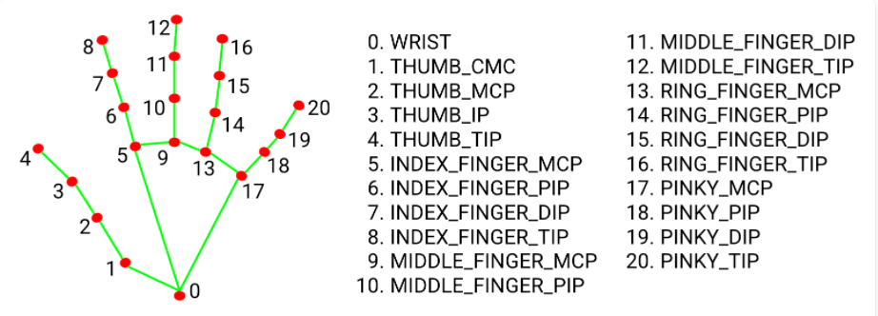

**Fig.6.1 Hand Detection points**

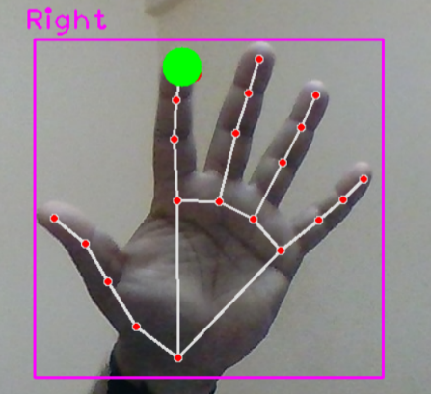

**Fig.6.2 Point of detection of the index figure**.

## Hand Movement

In this project we keep track of finger tips of the particular hands so for the free flow of the hands there is no restriction for the hand’s direction. When the system detects the hands, it particularly mentions hands if it is right or left hands. If our both hands are revealed towards the webcam the system detects only one hand at a time

## Food Item Display

In this game the snake ha to eat a particular food item for scoring a point, but these food items are allocated at different coordinates of the screen where these appear randomly on the screen every time when snake eats a food item it gets one point and also gets large in size.



**Fig.6.3 Food Item**.

## 6.1.5 Snake Projection

The main module after the hand detection is the “snake” in a snake game, in this project after the detection of the hands and as soon as hand movement starts there will be a green line surround by the red boundaries around the green line is the snake in the game.

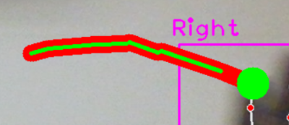

**Fig.6.4 Snake Projection**

## 6.1.6 Game Score

The game score is decided by the number of food item consumed by the snake where a particular food item represents one point and for every cycle the score will be added to the existing score and it will be displayed at left upper side corner of the screen

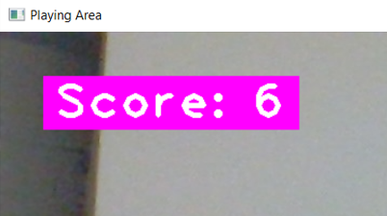

**Fig.6.5** **Game Score**.

**6.1.7 Snippet Code**

Below are the code snippets of the project which are used to build this game:

* **Installation of Modules:**

These are the packages that are need to be install for this project and the modules needed for the game are inside these packages

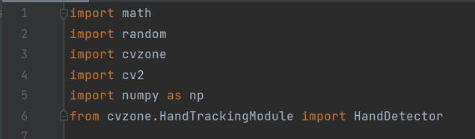

**Fig.6.6 Packages Installation**

* **Display Screen:**

This is the code for the dimensions of the screen where video capture is used to enable the web cam of the system

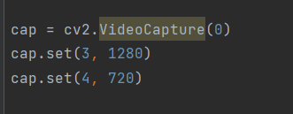

**Fig.6.7 Screen Dimension**

* **Hand Detection:**

This code is used for detecting the tips of the finger of the particular hand.



**Fig.6.8 Hand Detection**

* **Draw Snake:**

Responsible for the body of the snake or the projection of the snake.

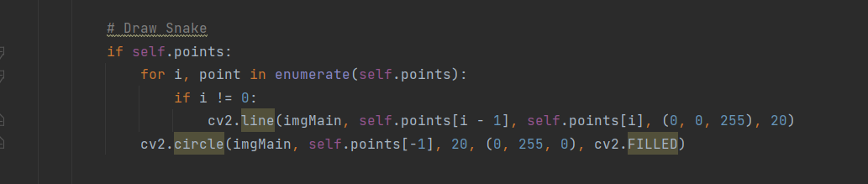

**Fig.6.9 Draw Snake**

* **Random Food Location:**

Food items are randomly allocated on the different position of the screen.



**Fig.6.10 Food Location**

* **Draw Food Items:**

To display the food item on the screen so that snake can eat the food item properly and to display the score of the game

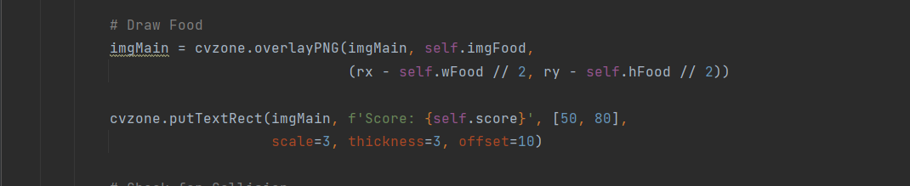

**Fig.6.11 Draw Food Item and Score**

* **Collision of Snake:**

The detection of the collision of the snake head with its own body during playing the game

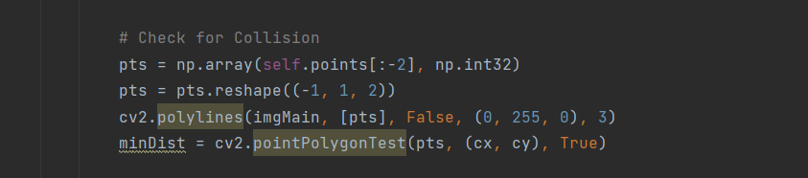

**Fig.6.12 Check Collision**

* **Game Score:**

Represents the game score where the game score is checked and the updated by one point

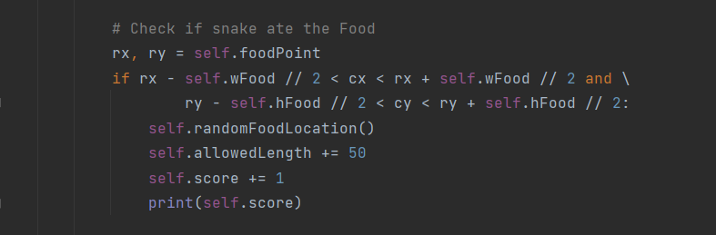

**Fig.6.13 Game Point**

* **Game Over:**

This displays the player score, when game is over a proper window is displayed where the score of the player is displayed with “Game Over” message.

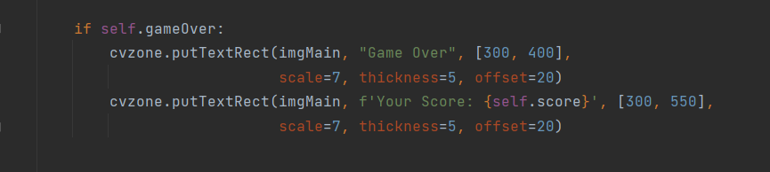

**Fig.6.14 Hand Detection**

**CHAPTER 7**

**SYSTEM TESTING**

System testing is a process of estimating the system to check whether it fit for the requirements or not and also identify the faults to ensure that product is defect free. System testing helps to increase the quality of the product from its components to entire system. If all the test cases are satisfied that produces a error free system.

Executing a program under test conditions ensures that specified input will result in actual results that are consistent with desired outputs. Error might start throughout any stage of the software project development process. There are various methods for identifying and removing faults that originate at each stage of the software development cycle. But certain mistakes will show up in the code. A very important part of quality control and assuring the depend abilities of the programs is testing. The system's design, development, testing, and implementation all affect the system's quality. Any of these areas that have weaknesses will significantly lower the system's value to its users and lower its overall quality.

**7.1 PURPOSE OF TESTING**

Various goals and objectives are involved in software testing. Following are some of the primary goals of software testing:

* Identifying any programming errors that may occur during software development.
* To stop flaws.
* To confirm that the outcome satisfies the needs of the user and the business.
* To make sure that it complies with the system requirements specifications (SRS)

Software testing is done to make sure that the finished piece of software performs as expected, as specified by the requirements and specifications. The ultimate goal is to identify circumstances that potentially have a detrimental impact on the customer, usability, and/or maintainability rather than to detect every software issue that has ever existed.

# 7.2 Testing Scenarios

**Table 7.1-Test Case Table**

|  |  |  |  |
| --- | --- | --- | --- |
| **Test Case Number** | **DESCRIPTION** | **EXPECTED RESULT** | **RESULT** |
| TC 1 | Click run for screen ratio and display without specifying pixels | Alert” Error” | PASS |
| TC 2 | Check Hand Detection with Camera | Detects all points of Hands | PASS |
| TC 3 | Check The Projection of Snake | Snake body appears on screen | PASS |
| TC 4 | Check for hand movement | Movement achieved properly | PASS |
| TC 5 | Food Item Allocation | Randomly allocated on screen | PASS |
| TC 6 | Snake eats the food item | Eats and scores are updated | PASS |
| TC 7 | Snake Length increase | Increases when eats food item | PASS |
| TC 8 | Collision detection | Detected and Ends game | PASS |
| TC 9 | No hand movement | Ends the game | PASS |
| TC 10 | Checking the game end | Displays the Score with a message | PASS |

# 7.3 Test Result Analysis

We have under gone different type of testing to make sure our project runs as expected. We have unit wise tested the components. We have tested the camera connectivity and modules connectivity and also, we have tested the screen delay. All the test cases are successfully passed. Then we have tested the scoring points in the game. We have verified the food items are at proper location where the snake can reach it to eat. All these test cases are successfully executed. We have tested the different test cases on collision, score updating. All these test cases are passed as expected.

**CHAPTER 8**

**RESULTS**



**Fig.8.1 Hand Detection**



**Fig.8.2 Points of Detection of hands**

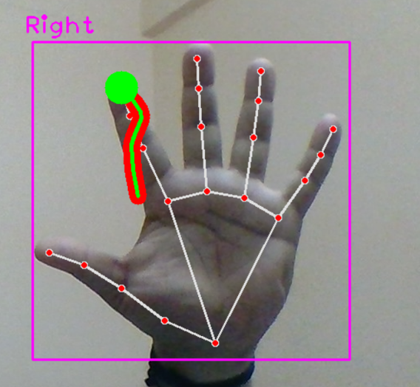

**Fig.8.3 Snake Body**

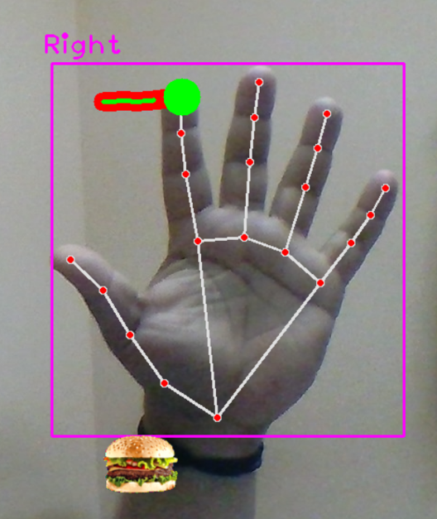

**Fig.8.4 Food Item Display**

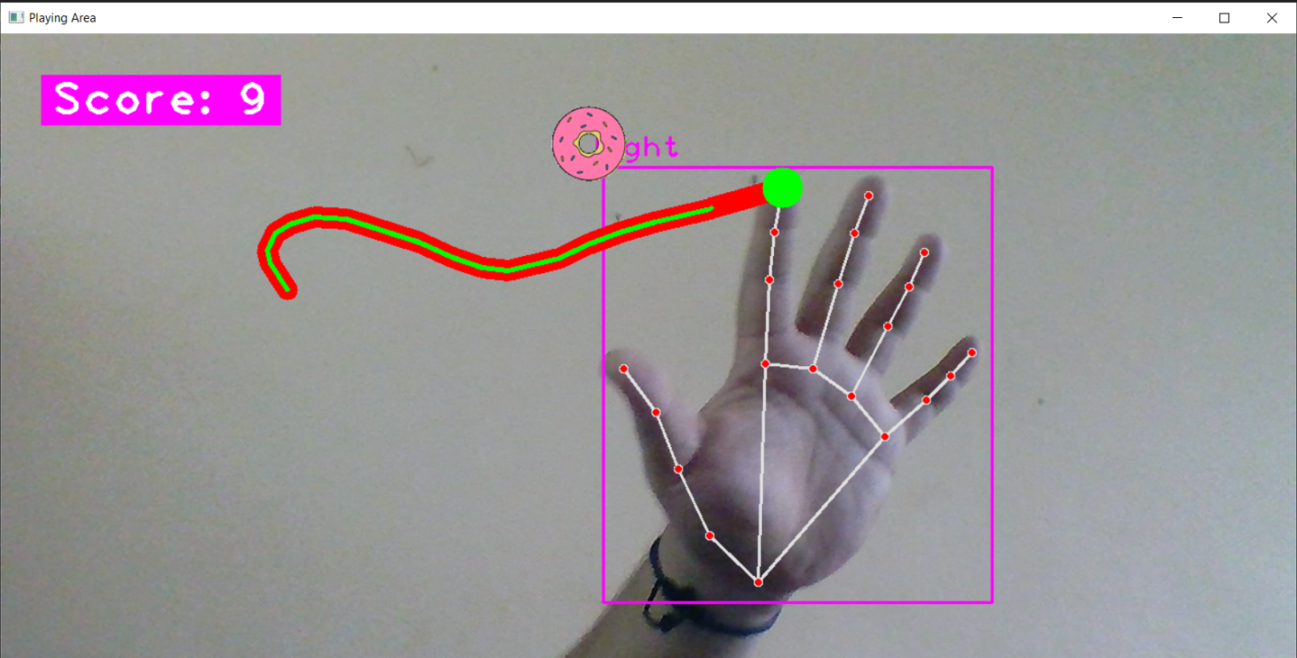

**Fig.8.5 On Screen Scores**

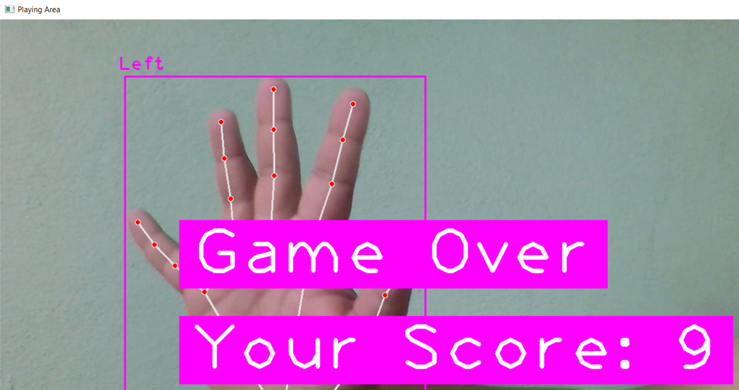

**Fig.8.6 Game Over with Scores**

**CONCLUSION**

The open-source computer vision (OpenCV) based hand tracking control is developed in the Python language. The project is able to control the snake in the game using hand tracking modules which the users have to detect the hand for playing a game. This game will perform by using hand tracking method where all the points of a particular hands are detected by the system. The system has the potential of detection of two hands where it gives chance to a particular hand it may be right or left depends on which hand is detected first. The accuracy of the hand tracking recognition is on to the point, it also recognition the hand perfectly whether it is right or left. Open CV mostly gives chance of innovation towards real-time vision applications and takes advantage of Multimedia Extension and Streaming SIMD Extensions (SSE) instructions

**FUTURE ENHANCEMENT**

In future we can implement this technology in various gamming fields where we can improve this technology by adding many more features not only in gamming industries, we can also build a computer system which is totally based on hand tracking technology.

**REFERENCES**

1. Tanay Thakar1, Rohit Saroj2, Prof Vidya Bharde3,“ Hand Gesture Controlled Gaming Application”, SCOPE School, Vellore Institute of Technology, Tamil Nadu , India.
2. Shikhar Singh , Dr. Swarnalatha P,“ Human Computer Interaction: Game Developed in Python using Gesture Recognition”, Department of Computer Engineering, MGM College of Engineering & Technology, Kamothe, Navi Mumbai, Maharashtra, India
3. Yashaswi Raj1 , Rajat Sharma2 “Snake Game Using Hand Recognition System”, Dept. of Computer Science & Engineering, MIET, Meerut, India
4. Kai Li1,2,3, Jun Cheng2,3, Qieshi Zhang*,2,3, Jianming Liu1 “Hand Gesture Tracking and Recognition based Human-Computer Interaction System and Its Applications” School of Computer Science and Information Security, Guilin University of Electronic Technology, Guilin, China, 2 Guangdong Provincial Key Laboratory of Computer Vision and Virtual Reality Technology, Shenzhen Institutes of Advanced Technology, Chinese Academy of Sciences, Shenzhen, China 3 The Chinese University of Hong Kong, Hong Kong, China

**URL’s**

1. https://docs.microsoft.com/en-us/azure/cognitive-services/computer-vision
2. https:// https://docs.python.org/3
3. https;//[www.PyCharm.cc/en/main/software](http://www.PyCharm.cc/en/main/software)
4. https://youtu.be/okAX72bfhGDK
5. https://youtu.be/nbD_V4QtNvY